Lab 1

Q: Create a Time-Table using HTML Table tags of your respective division.

TAGS USED | ATTRIBUTES USED | DESCRIPTION
<!DOCTYPE  html> | — | Declares the document as an HTML5 document.
<html> | lang="en" | Root element of the HTML document and specifies the language as English.
<head> | — | Contains metadata and information about the HTML document.
<meta> | charset="UTF-8" | Specifies the character encoding of the document as UTF-8.
<meta> | name="viewport", content="width=device-width, initial-scale=1.0" | Makes the webpage responsive on different screen sizes.
<title> | — | Specifies the title shown in the browser tab.
<body> | — | Contains all the visible content of the webpage.
<table> | border="1" | Creates a table with a 1-pixel border.
<tr> | — | Defines a row in the table.
<td> | rowspan, colspan, style | Defines a table cell. row span merges rows, Col span merges columns, and style applies inline CSS such as background color.
<img> | src="mu logo.png" | Displays an image. The src attribute specifies the image file path.
<p> | — | Defines a paragraph to display text.
<pre> | — | Displays preformatted text  while preserving spaces and line breaks.
<!-- ... --> | — | Adds comments in the HTML code that are not displayed in the browser.

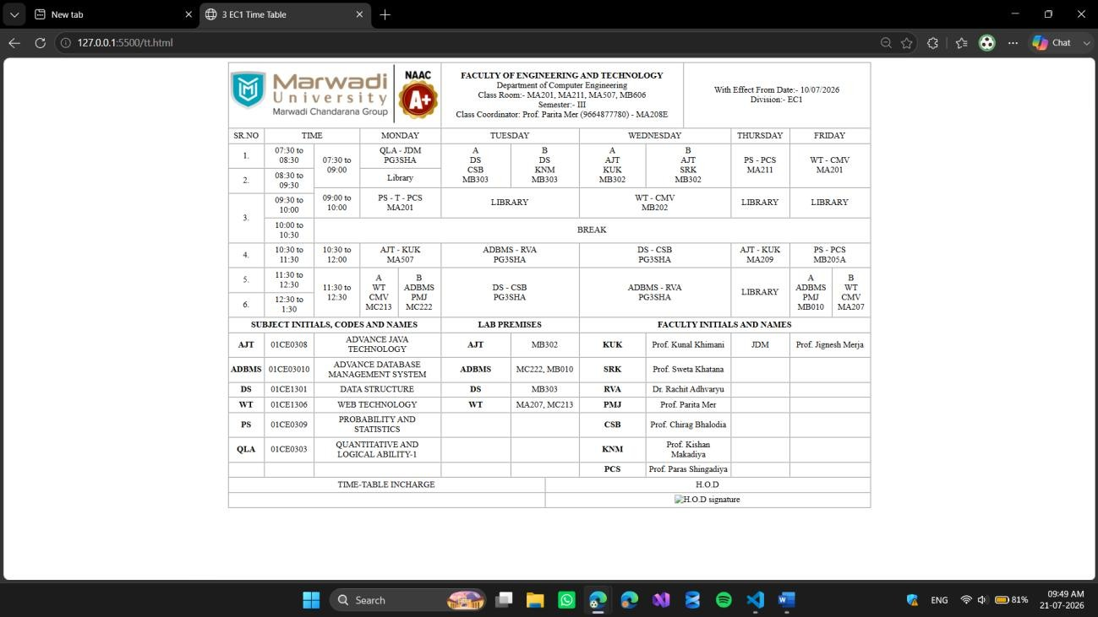
Final Outcome:

Code Snippet:

<!DOCTYPE html>
<html lang="en">
<head>
<meta charset="UTF-8">
<title>3 EC1 Time Table</title>
</head>
<body>
<center>
<font face="Times New Roman">
<table border="1" cellspacing="0" cellpadding="4" width="1200">
<tr>
<td rowspan="7" colspan="7" width="180" align="center"><img src="R.png" alt="Marwadi University logo" width="100%"></td>
<td rowspan="7" colspan="7" width="520" align="center">
<strong>FACULTY OF ENGINEERING AND TECHNOLOGY</strong><br>
Department of Computer Engineering<br>
Class Room:- MA201, MA211, MA507, MB606<br>
Semester:- III<br>
Class Coordinator: Prof. Parita Mer (9664877780) - MA208E
</td>
<td rowspan="7" colspan="11" width="500" align="center"> With Effect From Date:- 10/07/2026<br>
Division:- EC1
</td>
</tr>
<tr></tr>
<tr></tr>
<tr></tr>
<tr></tr>
<tr></tr>
<tr></tr>
<tr>
<td align="center">SR.NO</td>
<td colspan="2" align="center">TIME</td>
<td colspan="4" align="center">MONDAY</td>
<td colspan="4" align="center">TUESDAY</td>
<td colspan="4" align="center">WEDNESDAY</td>
<td colspan="4" align="center">THURSDAY</td>
<td colspan="4" align="center">FRIDAY</td>
</tr>

<tr>
<td rowspan="2" align="center">1.</td>
<td rowspan="2" align="center">07:30 to 08:30</td>
<td rowspan="3" align="center">07:30 to 09:00</td>
<td rowspan="2" colspan="4" align="center">QLA - JDM<br>PG3SHA</td>
<td rowspan="3" colspan="2" width="240" align="center">A<br>DS<br>CSB<br>MB303</td>
<td rowspan="3" colspan="2" width="240" align="center">B<br>DS<br>KNM<br>MB303</td>
<td rowspan="3" colspan="2" width="240" align="center">A<br>AJT<br>KUK<br>MB302</td>
<td rowspan="3" colspan="2" width="240" align="center">B<br>AJT<br>SRK<br>MB302</td>
<td rowspan="3" colspan="4" align="center">PS - PCS<br>MA211</td>
<td rowspan="3" colspan="4" align="center">WT - CMV<br>MA201</td>
</tr>
<tr></tr>
<tr>
<td rowspan="2" align="center">2.</td>
<td rowspan="2" align="center">08:30 to 09:30</td>
<td colspan="4" align="center">Library</td>
</tr>
<tr>
<td rowspan="2" align="center">09:00 to 10:00</td>
<td rowspan="3" colspan="4" align="center">PS - T - PCS<br>MA201</td>
<td rowspan="3" colspan="4" align="center">LIBRARY</td>
<td rowspan="3" colspan="4" align="center">WT - CMV<br>MB202</td>
<td rowspan="3" colspan="4" align="center">LIBRARY</td>
<td rowspan="3" colspan="4" align="center">LIBRARY</td>
</tr>
<tr>
<td rowspan="3" align="center">3.</td>
<td align="center">09:30 to 10:00</td>
</tr>
<tr></tr>
<tr>
<td align="center">10:00 to 10:30</td>
<td colspan="20" align="center">BREAK</td>
</tr>
<tr>
<td rowspan="2" align="center">4.</td>
<td rowspan="2" align="center">10:30 to 11:30</td>

<td rowspan="3" align="center">10:30 to 12:00</td>
<td rowspan="3" colspan="4" align="center">AJT - KUK<br>MA507</td>
<td rowspan="3" colspan="4" align="center">ADBMS - RVA<br>PG3SHA</td>
<td rowspan="3" colspan="4" align="center">DS - CSB<br>PG3SHA</td>
<td rowspan="3" colspan="4" align="center">AJT - KUK<br>MA209</td>
<td rowspan="3" colspan="4" align="center">PS - PCS<br>MB205A</td>
</tr>
<tr></tr>
<tr>
<td rowspan="2" align="center">5.</td>
<td rowspan="2" align="center">11:30 to 12:30</td>
</tr>
<tr>
<td rowspan="3" align="center">11:30 to 12:30</td>
<td rowspan="3" colspan="2" align="center">A<br>WT<br>CMV<br>MC213</td>
<td rowspan="3" colspan="2" align="center">B<br>ADBMS<br>PMJ<br>MC222</td>
<td rowspan="3" colspan="4" align="center">DS - CSB<br>PG3SHA</td>
<td rowspan="3" colspan="4" align="center">ADBMS - RVA<br>PG3SHA</td>
<td rowspan="3" colspan="4" align="center">LIBRARY</td>
<td rowspan="3" colspan="2" align="center">A<br>ADBMS<br>PMJ<br>MB010</td>
<td rowspan="3" colspan="2" align="center">B<br>WT<br>CMV<br>MA207</td>
</tr>
<tr>
<td rowspan="2" align="center">6.</td>
<td rowspan="2" align="center">12:30 to 1:30</td>
</tr>
<tr></tr>
<tr></tr>
<tr>
<td colspan="7" align="center"><strong>SUBJECT INITIALS, CODES AND NAMES</strong></td>
<td colspan="5" align="center"><strong>LAB PREMISES</strong></td>
<td colspan="11" align="center"><strong>FACULTY INITIALS AND NAMES</strong></td>
</tr>
<tr>
<td align="center"><strong>AJT</strong></td>
<td align="center">01CE0308</td>
<td colspan="5" align="center">ADVANCE JAVA TECHNOLOGY</td>
<td align="center"><strong>AJT</strong></td>
<td colspan="4" align="center">MB302</td>
<td align="center"><strong>KUK</strong></td>

<td colspan="4" align="center">Prof. Kunal Khimani</td>
<td align="center">JDM</td>
<td colspan="5" align="center">Prof. Jignesh Merja</td>
</tr>
<tr>
<td align="center"><strong>ADBMS</strong></td>
<td align="center">01CE03010</td>
<td colspan="5" align="center">ADVANCE DATABASE MANAGEMENT SYSTEM</td>
<td align="center"><strong>ADBMS</strong></td>
<td colspan="4" align="center">MC222, MB010</td>
<td align="center"><strong>SRK</strong></td>
<td colspan="4" align="center">Prof. Sweta Khatana</td>
<td></td>
<td colspan="4"></td>
</tr>
<tr>
<td align="center"><strong>DS</strong></td>
<td align="center">01CE1301</td>
<td colspan="5" align="center">DATA STRUCTURE</td>
<td align="center"><strong>DS</strong></td>
<td colspan="4" align="center">MB303</td>
<td align="center"><strong>RVA</strong></td>
<td colspan="4" align="center">Dr. Rachit Adhvaryu</td>
<td></td>
<td colspan="4"></td>
</tr>
<tr>
<td align="center"><strong>WT</strong></td>
<td align="center">01CE1306</td>
<td colspan="5" align="center">WEB TECHNOLOGY</td>
<td align="center"><strong>WT</strong></td>
<td colspan="4" align="center">MA207, MC213</td>
<td align="center"><strong>PMJ</strong></td>
<td colspan="4" align="center">Prof. Parita Mer</td>
<td></td>
<td colspan="4"></td>
</tr>
<tr>
<td align="center"><strong>PS</strong></td>
<td align="center">01CE0309</td>
<td colspan="5" align="center">PROBABILITY AND STATISTICS</td>

<td></td>
<td colspan="4"></td>
<td align="center"><strong>CSB</strong></td>
<td colspan="4" align="center">Prof. Chirag Bhalodia</td>
<td></td>
<td colspan="4"></td>
</tr>
<tr>
<td align="center"><strong>QLA</strong></td>
<td align="center">01CE0303</td>
<td colspan="5" align="center">QUANTITATIVE AND LOGICAL ABILITY-1</td>
<td></td>
<td colspan="4"></td>
<td align="center"><strong>KNM</strong></td>
<td colspan="4" align="center">Prof. Kishan Makadiya</td>
<td></td>
<td colspan="4"></td>
</tr>
<tr>
<td align="center"></td>
<td></td>
<td colspan="5"></td>
<td></td>
<td colspan="4"></td>
<td align="center"><strong>PCS</strong></td>
<td colspan="4" align="center">Prof. Paras Shingadiya</td>
<td></td>
<td colspan="4"></td>
</tr>
<tr>
<td colspan="10" align="center">TIME-TABLE INCHARGE</td>
<td colspan="13" align="center">H.O.D</td>
</tr>
<tr>
<td colspan="10"></td>
<td colspan="13" align="center"><img src="kunal sir sign" alt="H.O.D signature"></td>
</tr>
</table>
</font>
</center>
</body>
</html>

